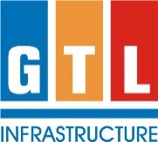

Investor Grievance | For the purpose of determining materiality of an event or Information
Name & Designation | Name & Designation
Mr. Deepak Keluskar - Company Secretary | Mr. Jayant L. Bhimanwar – Whole-time Director
 | Mr. Ajit M. Shanbhag - Chief Financial Officer
 | Mr. Deepak Keluskar - Company Secretary
Registered Office Address: GTL Infrastructure Limited, 7th Floor, Building No. A, Plot No. EL-207, MIDC, TTC Industrial Area, Mahape, Navi Mumbai - 400 710 Tel. No. +91-22-68293500 Email address: gilshares@gtlinfra.com

